Project Name: ____________________________________________
Date: ______________________________________
Template Instructions:
With the project team, brainstorm all the people that are impacted by the project, including the project team members. With the team, try to come up with as many stakeholder groups and individuals as you can. DO NOT miss anyone important.

Identify the stakeholders by group or name first, along with their contact information (email and/or phone), then move to the next column and identify what each stakeholder’s role in the project is. If necessary, add another column to state the position or the title of each stakeholder.

Next, move to the project/phase column to identify what each stakeholder is interested in during the project lifecycle (i.e., design, testing, etc.) This will help you identify which of those stakeholders should be communicated with based on each project phase. It is also possible to have a separate stakeholder register for each project phase for larger projects and diverse stakeholder groups.
After, start identifying the requirements and expectations of each stakeholder, such as what communications requirements or expectations for the project they may have. If some requirements are unclear or are unknown, consult senior management, or ask the stakeholder to identify their requirements and what they expect to get from the project.
To ensure that the right communicated information is shared with the right stakeholder, you need to identify whether or not the stakeholder is external or internal to the project or organization. In other words, external stakeholders should not have access to internal, confidential information.
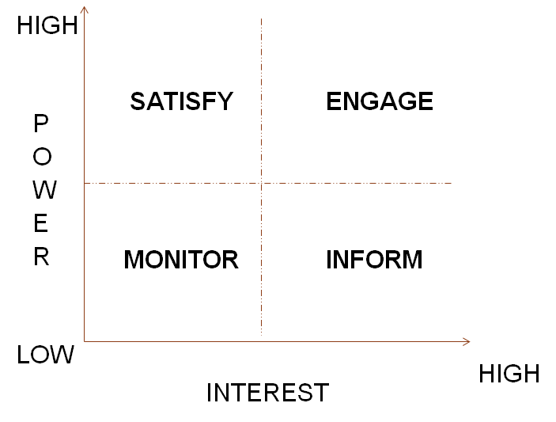
Finally, each stakeholder should be given a score from 1 to 5 (1 is low, 5 is high) that states the power and the interest they have in the project. Project professionals often use what’s called a Power-Interest Grid to determine how to best manage stakeholders. The Power-Interest Grid divides stakeholders into four quadrants, based on what you and the team believe to be their power and interest levels. The quadrant the stakeholder belongs to informs the team how to manage the stakeholder best:
Low power-low interest: Monitor these stakeholders to make sure you correctly identified their level of power-interest. Also, check periodically during the project to make sure their level does not change.
Low power-high interest: Keep these stakeholders “in the loop.” Make sure they receive the right messages, in the right format, at the right times for their group.
High power-low interest: Keep these stakeholders satisfied. Conduct periodic reviews or surveys, or other lower engagement means to determine satisfaction levels. Ignoring a high power and low-interest individual may lead to sudden project issues as they use their power and influence to attempt to address their dissatisfaction.
High power-high interest: Keep these stakeholders actively engaged. They need to be consulted, given tasks, and periodically involved in some way in the project. They will be influencers in how work is done and can have a large positive or negative impact on projects.

Name | Contact Information | Role | Project Phase | Requirements/ Expectations | Internal/  External | Power | Interest

Prefilled Example:
Name | Contact Information | Role | Project Phase | Requirements/ Expectations | Internal/  External | Power | Interest
Jim | jim@m-vault.com | Client, Product Owner | All | Project delivered that delights customers | External | 5 | 5
Dennis | dennis@xanadu.com | Project Sponsor | All | Bi-weekly status updates and 1-1 meeting, a project delivered that meet’s Jim’s approval | Internal | 5 | 5
Siwan | siwan@xanadu.com | PM (me) | All | Conduct project per the PROJECT methodology | Internal | 4 | 5
Xanadu Functional Managers | barbara@xanadu.com  quincy@xanadu.com | Manage resources | All | Weekly status updates, monthly briefing about resource utilization | Internal | 4 | 4
Movie Vault Content Team | Contact via Jim | Project end users | Planning (some), Transfer | Participate in project requirements elicitation and receive an excellent product that meets their needs; Jim will provide reports to them | External | 3 | 4
Movie Vault Security Manager | security@m-vault.com | Project end user | Planning (some), Transfer | Participate in project requirements elicitation and receive an excellent product that meets their needs; Jim will provide reports to them | External | 3 | 4
Movie Vault customers | Contact via Jim | Project end users | Transfer | Receive an excellent product that meets their needs; Jim will monitor for changes | External | 3 | 1
… | … | … | … | … | … | … | …

